**Cloudera Trial**

**Installation**

**in Ubuntu Machine**

# **Set Up a Cluster Using the Wizard**

* Upload the license
* Add the Private cloud Cluster
* Generate CA
* Specify all hosts
* Select the repository
* Select JDK version which is java-1.8.0-openjdk-devel
* Install the agents
* Install the parcel
* Inspect cluster

**Specify all hosts**

In this step we defined a name for our cluster as "bdaktprod-cluster" and then added all hosts into it by adding IP address or hostnames

**Select the repository**

The repository which we created in the first step of installation is to be provided in this step. The Cloudera Manager uses same repository to copy required installation files to rest of the servers. The same installation files (parcels) are then used to install required services and roles.

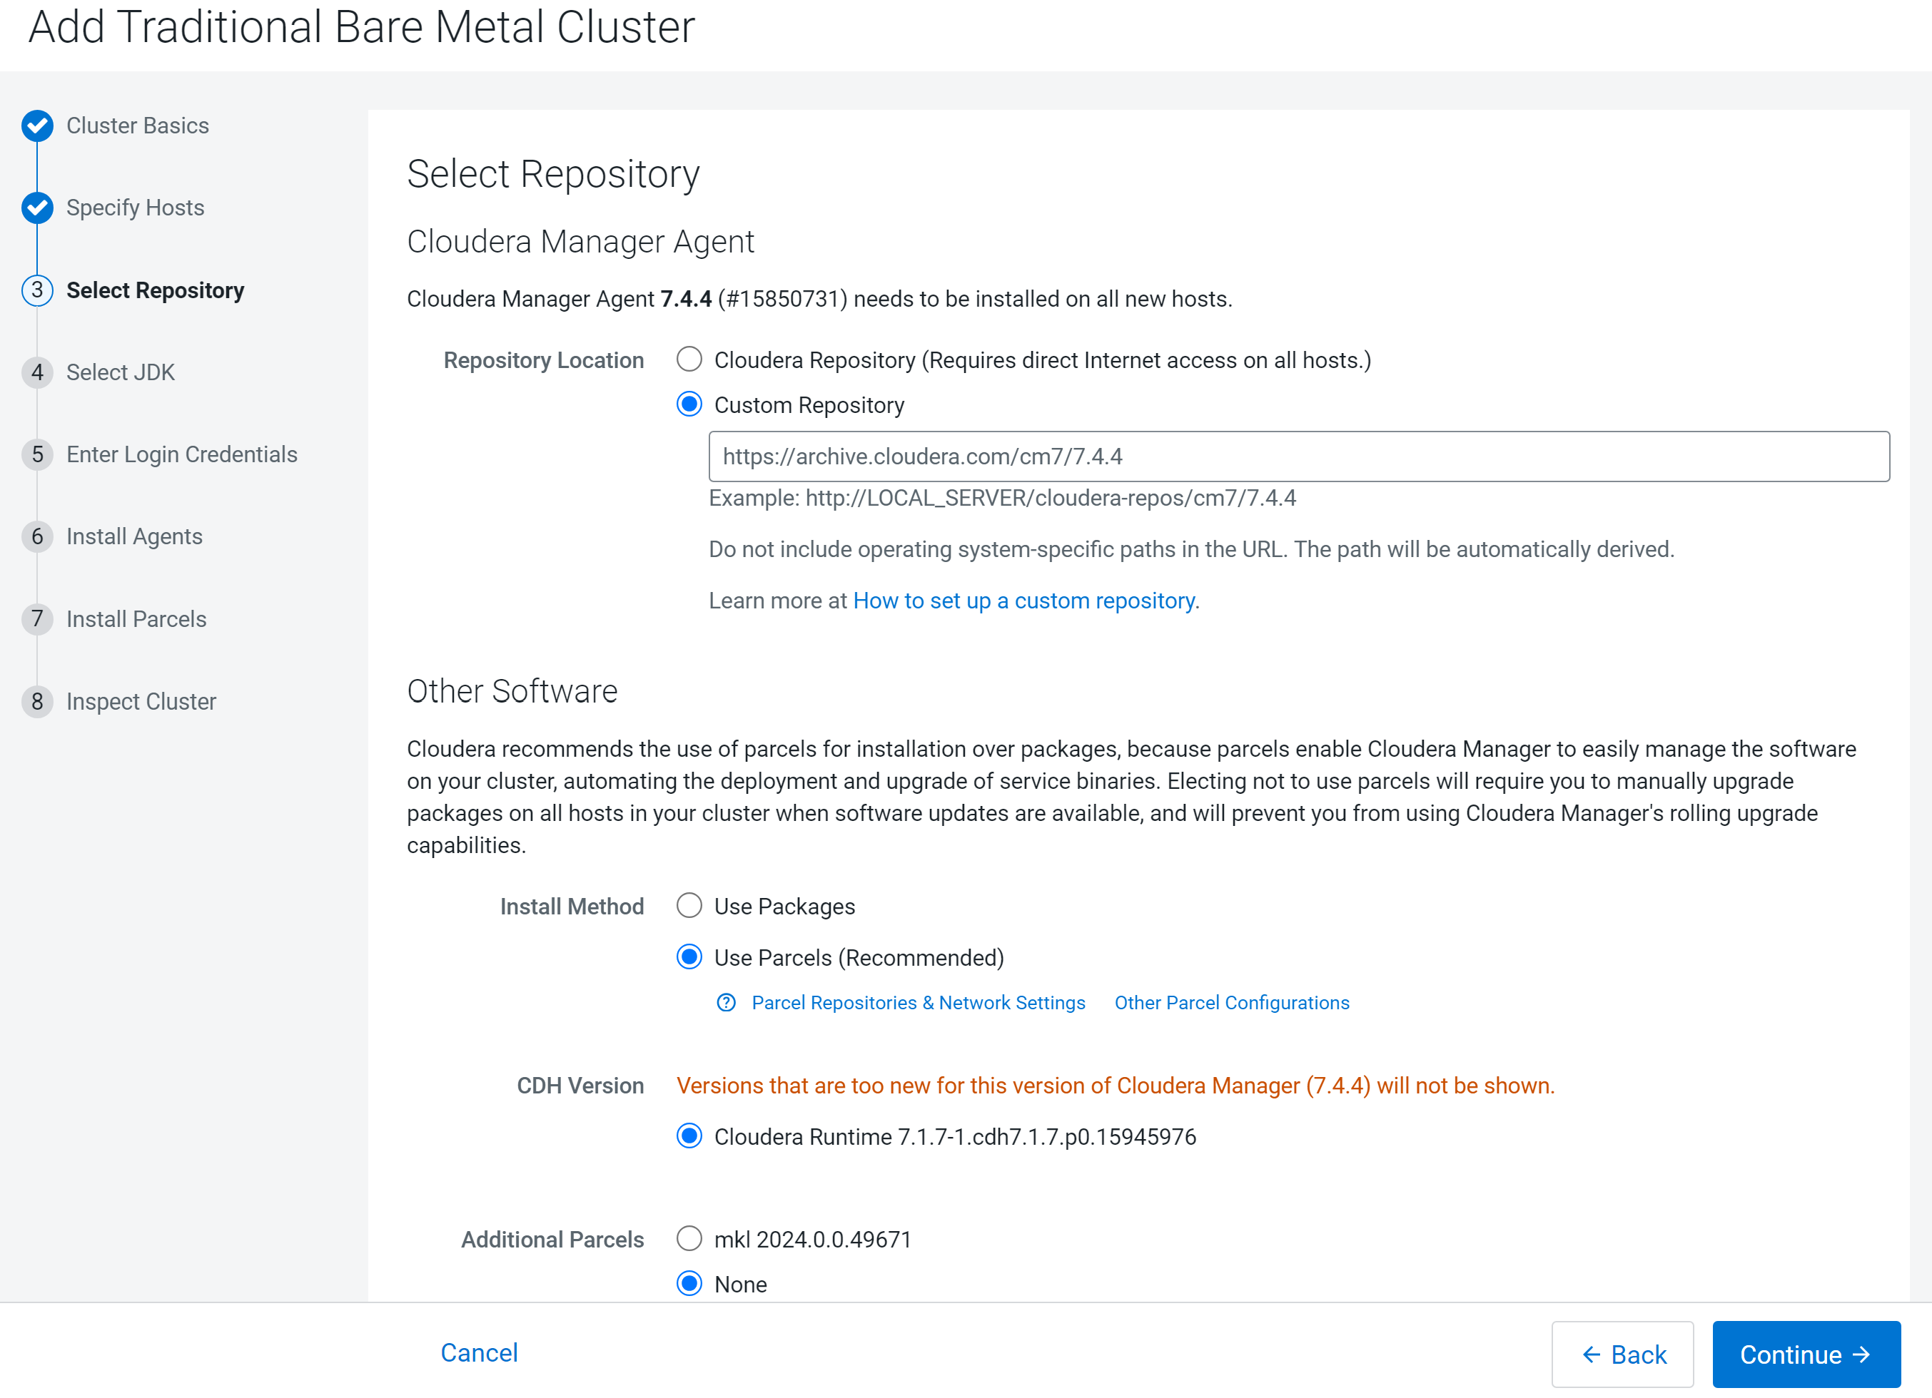

**Select the JDK**

If the JDK is not managed by the OS, we have the flexibility to install JDK by Cloudera Manager automatically. Since in our case, JDK was readily available in the OS, we skipped this step.

**Enter Login Credentials**

We need to provide the credentials to be used for installation, starting and stopping of Cloudera related services.

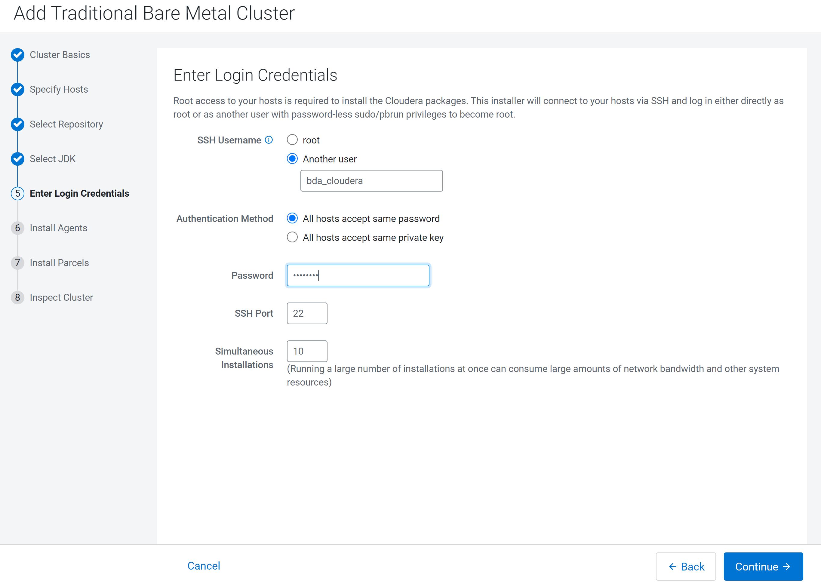

**Install the Agents**

In this step, Cloudera Manager agents are installed on all the servers which are made part of the cluster in previous step (Specify Hosts).

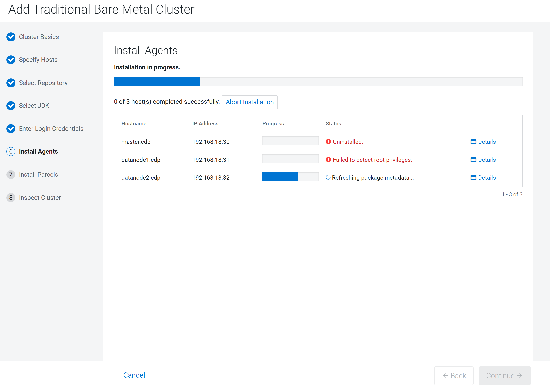

**Install the parcels**

In this step, Cloudera copies all required installation files from the Repository configured in the previous step to all the server hosts added into the cluster.

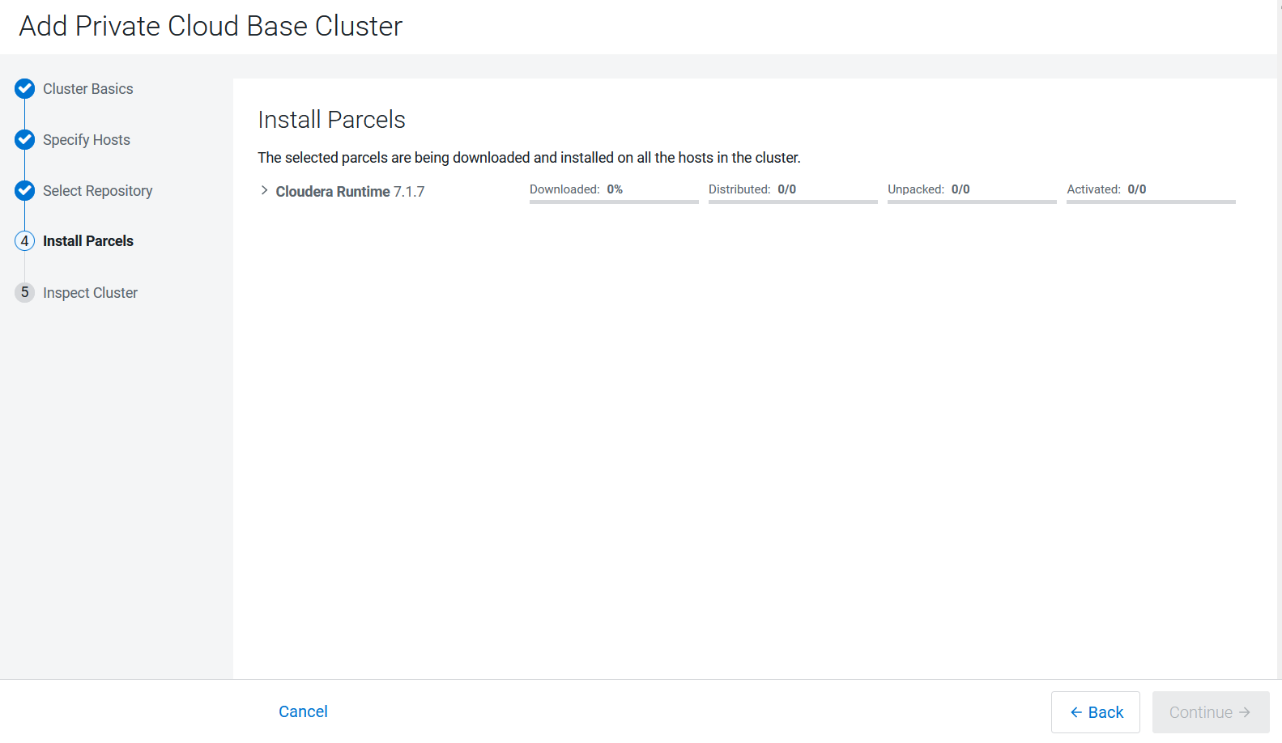

**Inspect Cluster**

